**Jersey City CitiBike Analyses**

**January 1, 2017 to February 28, 2018**

1. **How many trips have been recorded total during the chosen period?**

There were 355,054 unique trips recoded from January 1, 2017 to February 28, 2018.

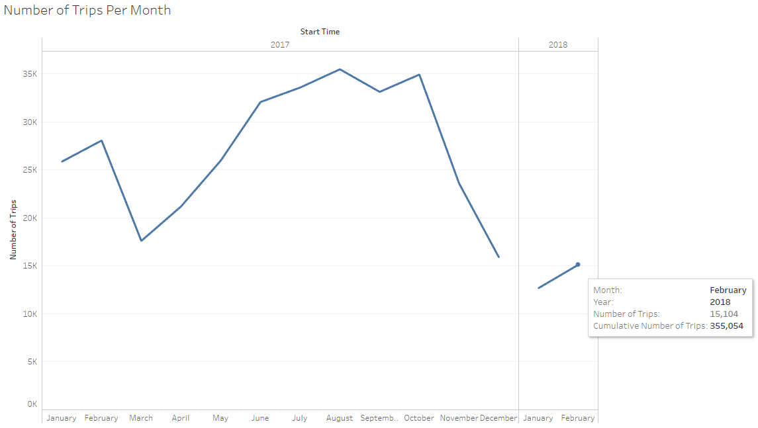

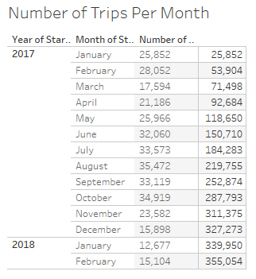

1. **By what percentage has total ridership grown?**

Ridership grew 1,274% from January 1, 2017 to February 28, 2018.

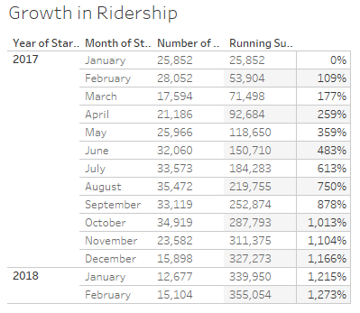

1. **How has the proportion of short-term customers and annual subscribers changed?**

Throughout the time period, the vast majority of riders were annual subscribers as opposed to short-term customers. More short-term customers appear to be utilizing CitiBike during the warm months, from April to October, then the number dips during colder months. This indicates that people may be more tempted to check out a bike ad hoc during good weather.

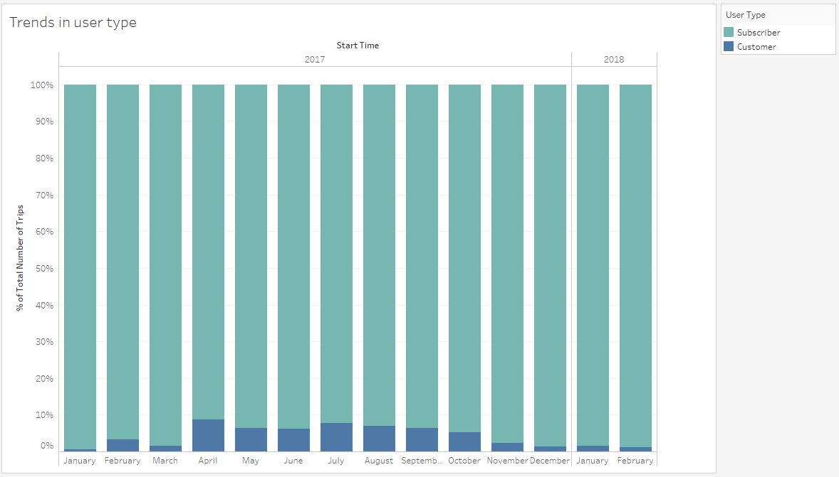

1. **Today, what are the peak hours in which bikes are used during summer months?**

Unsurprisingly, peak hours in both the summer and winter occur during regular commute times, around 8-9AM and 5-6.30PM. There is a small but unsurprising boost around lunch time.

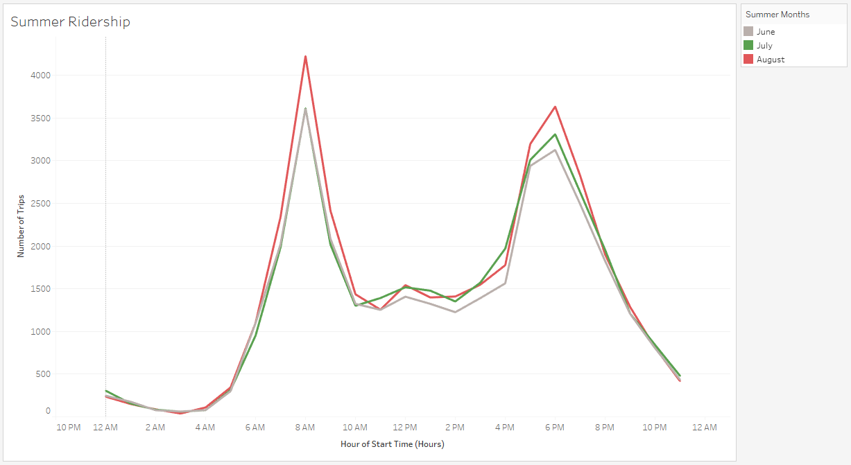

1. **Today, what are the peak hours in which bikes are used during winter months?**

Unsurprisingly, peak hours in both the summer and winter occur during regular commute times, around 8-9AM and 5-6.30PM. There is also a small but unsurprising boost around lunch time. Ridership is notably lower in December, possibly because of less commuting for work during the holidays or the weather.

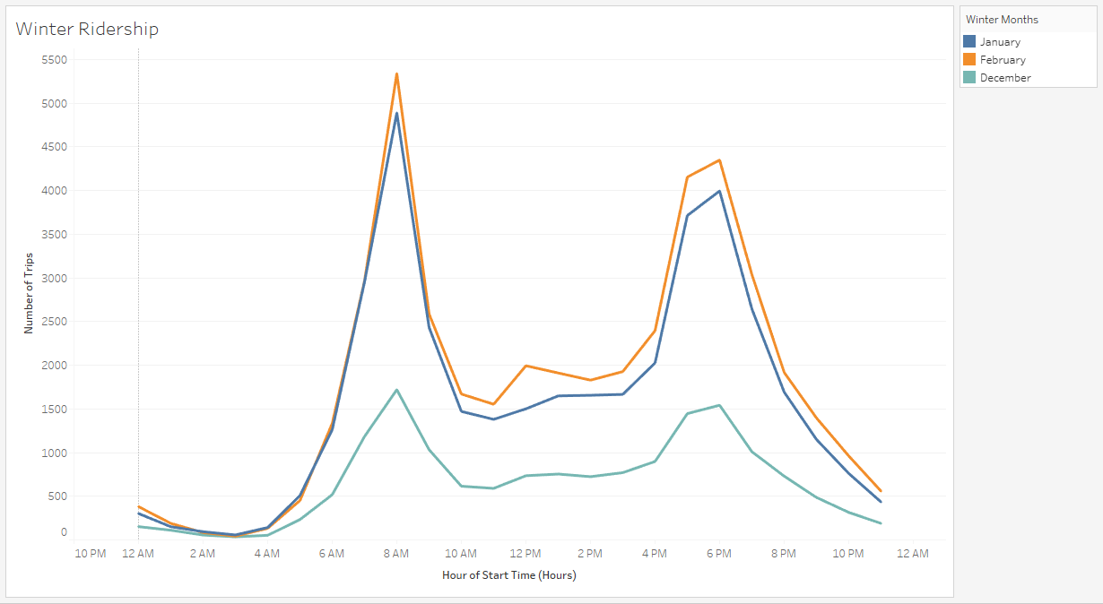

1. **Today, what are the top 10 stations in the city for starting a journey? (Based on data, why do you hypothesize these are the top locations?)**

The top 10 starting stations are below. Interpretation follows.

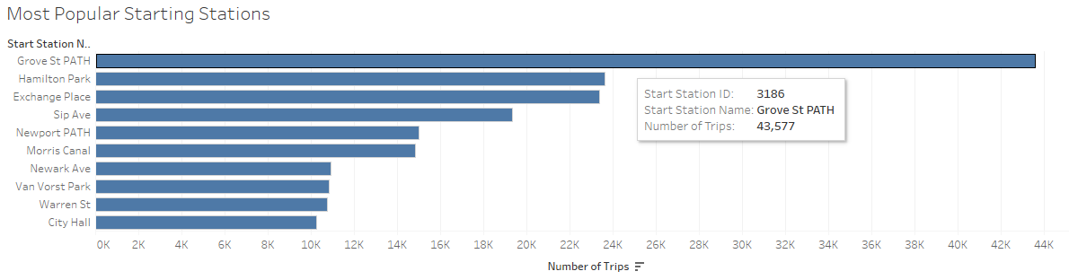

1. **Today, what are the top 10 stations in the city for ending a journey? (Based on data, why?)**

The top 10 ending stations are below. Interpretation follows.

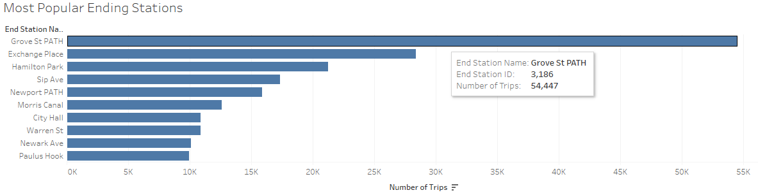

1. **Today, what are the bottom 10 stations in the city for starting a journey? (Based on data, why?)**

The bottom 10 starting stations are below. Interpretation follows.

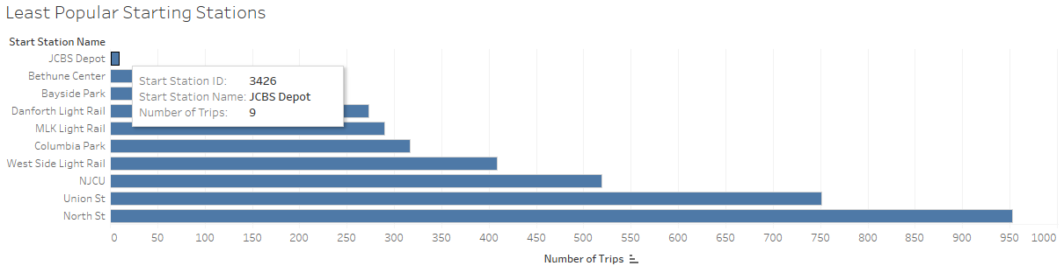

1. **Today, what are the bottom 10 stations in the city for ending a journey (Based on data, why?)**

The bottom 10 ending stations are below. Interpretation follows.

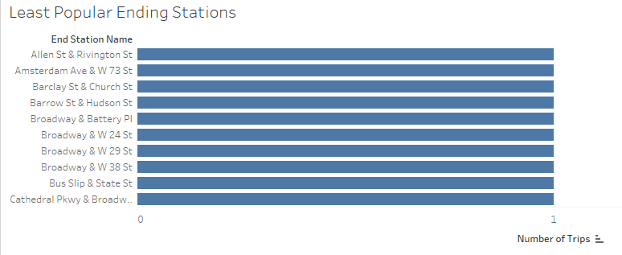

**6 & 8. Reasons for top and bottom 10 starting stations.**

All starting stations in the Jersey City CitiBike dataset are below. The 10 most popular are in teal and the 10 least popular are in orange. The gray overlay represents median household income in 2018. The most popular stations are clustered on the east side of the city with more businesses and with closer to access to Manhattan, while the least popular are the furthest away. Given that ridership peaks during rush hours, this may indicate that proximity to areas with higher concentrations of businesses lead to higher ridership.

Popular stations also tend to be in areas with higher median incomes while less popular stations are in areas with lower median incomes. It’s possible that individuals who can afford to live closer to business hubs tend to use CitiBike more often. Individuals with lower median incomes live further away from hubs and also may work further away from where they live, outside of bike-commuting distance.

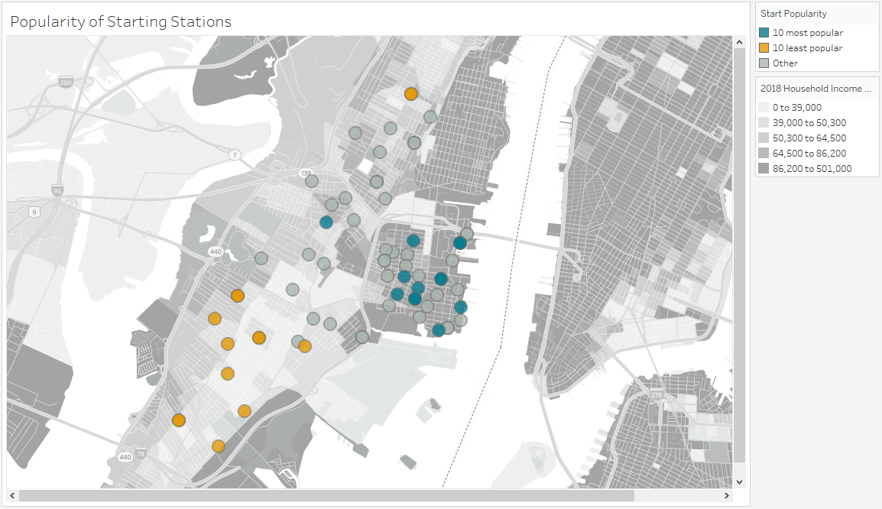

**7 & 9. Reasons for top and bottom 10 ending stations.**

All ending stations in the Jersey City CitiBike dataset are below. The 10 most popular are in teal and the 10 least popular are in orange. As discussed above, it looks like Manhattan is a popular destination for Jersey City CitiBike users, based on the number of ending stations located there. However, Manhattan destinations are still a long distance away from Jersey City so the least popular stations tend to be further from bridges and other access points. The most popular stations are still clustered on the east side of Jersey City, which makes sense if these locations are close to business hubs but are still within the city.

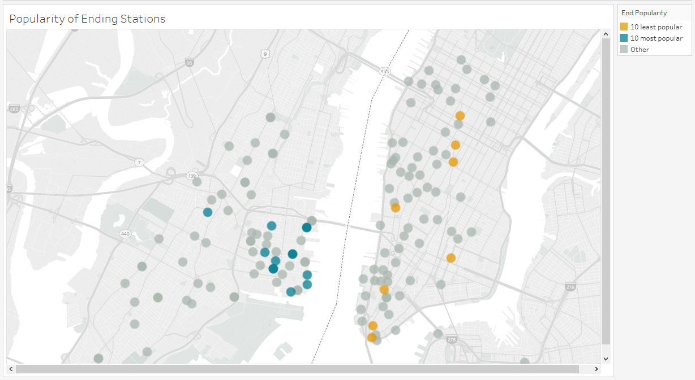

1. **Today, what is the gender breakdown of active participants (Male v. Female)?**

The most recent date with data available was February 28, 2018. The vast majority of riders with known genders -- 82.6% -- were male.

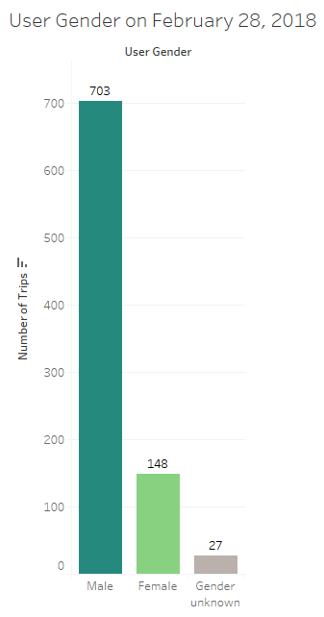

1. **How effective has gender outreach been in increasing female ridership over the course of the past year?**

Gender outreach does not seem to be very effective. The proportion of female riders is almost flat, with small increases and decreases that mirror the weather.

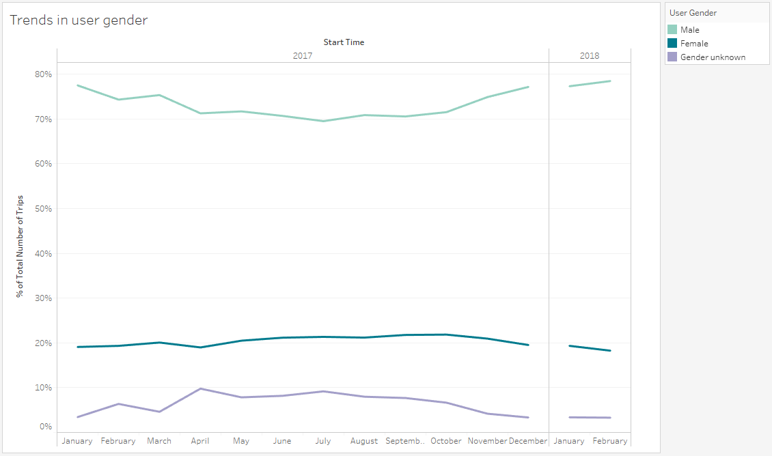

1. **How does the average trip duration change by age?**

There were many age outliers – up to about 130 years old, but I restricted the maximum to 80. Average trip duration is much higher between the ages of about 17 and 20, averaging almost 2.5 hours, then declines. Riders in their early 20s take longer trips then it levels it around age 24, with few noticeably peaks and valleys. It is possible that riders who may still be in school may be choosing to ride a bike longer distances so that they don’t have to pay for alternative, more expensive modes of transportation such as the subway. The peak hour analyses suggest that most riders are commuting to and from work. Therefore, older riders may be more likely to commute short distances to work and may be more likely to live a short ride away from work and business hubs.

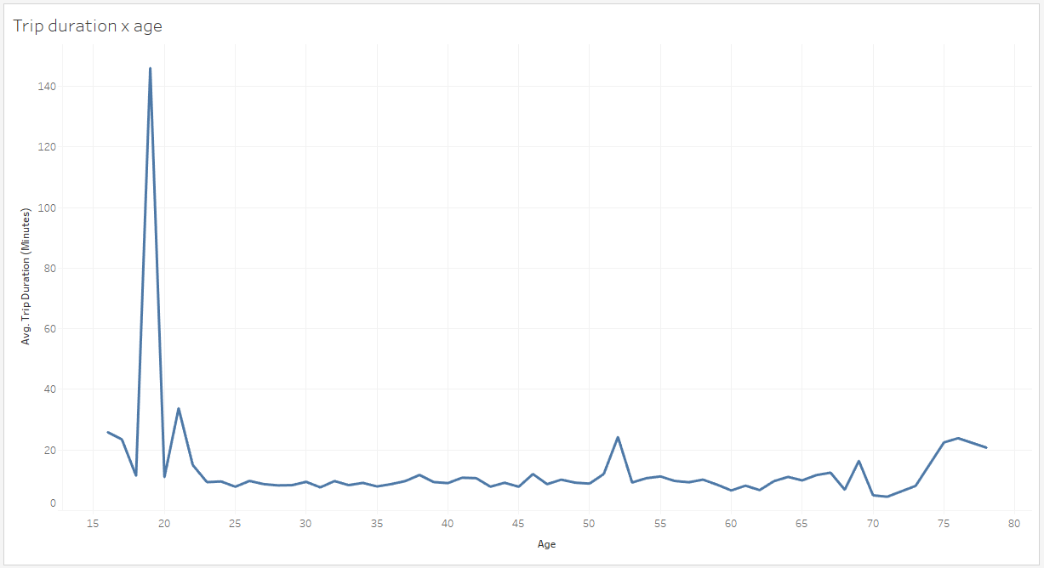

1. **What is the average distance in miles that a bike is ridden?**



1. **Which Bikes (by ID) are most likely due for repair or inspection this year?**

Assuming that bike mileage strongly impacts the likelihood of a bike needing repair or inspection, the bikes with the most mileage should be inspected first. The bike IDs ordered by mileage are below.

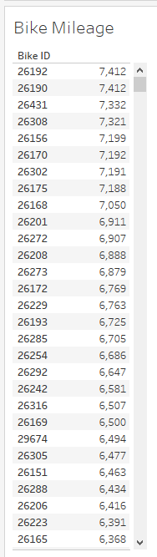

1. **How variable is the utilization by bike ID?**

Utilization by bike ID is extremely variable, with some bikes being ridden only once over the entire time period and the most popular being ridden almost 1000 times. Although there are thousands of bikes and it is impossible to track the usage of a single bike over the time period, the sheer chaos of the line chart suggests that utilization is extremely variable both between and within bikes.

